Assignment 4
Domain Model Implementation
The purpose of this assignment is to implement the Domain Model. Finally. The fun stuff!
All assignments will be handed in through GitHub, and you must follow the structure described in the assignment descriptions.
First, follow the below steps to setup your project for assignment 4.

I recommend that you read through everything, before you actually start doing anything.

1 Initial Setup

Create folder
In the Documentation project, create a new folder, call it Assignment4. Here goes the documentation for this assignment. This includes a markdown file with a status overview of which use cases and scenarios have been completed, and which are missing. Like this:
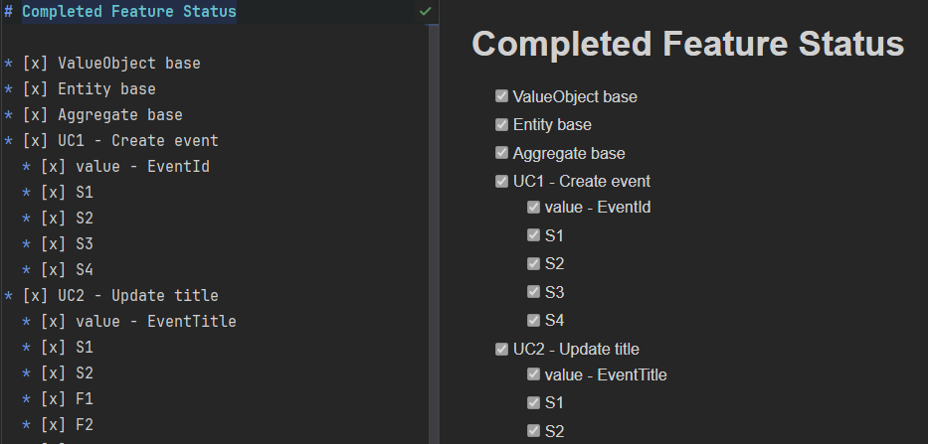

2 Solution setup
Again, we start by setting up a good solution structure. We will mainly be working within the Domain project, and UnitTests project.

Domain Project Setup:
First, you need the Domain project. It’s a Class Library. It goes into the Core solution folder, like this:
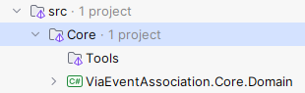
Notice naming of the project, to create the correct namespace. Make sure to have the physical location match as well:
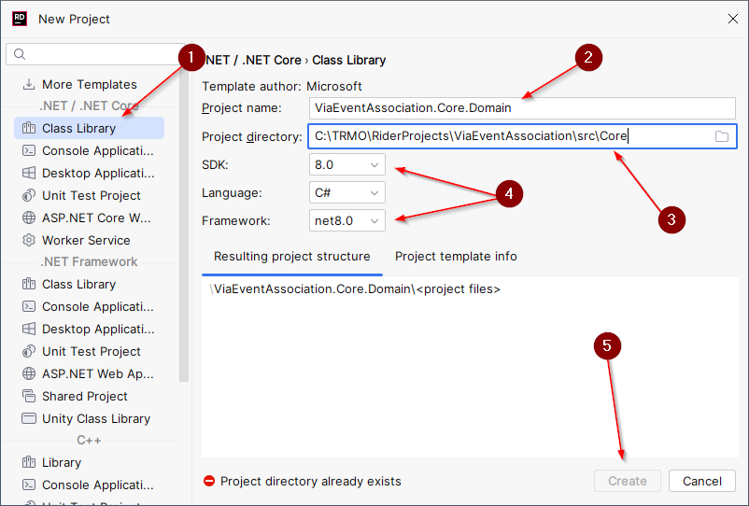

Now, the next part discusses setup of directories.
Folders will not be pushed to GitHub until they have files in them, so just create the folders when you need to, or create and commit a dummy file. Read through the following, to understand the setup, we are aiming for!

Domain Setup:
Base classes directory
We need base classes for AggregateRoot, Entity, and ValueObject, and maybe others.
Create a “Common” directory. Here we put stuff which may be shared across the Domain project, and may not otherwise have an obvious location.
Create a directory inside “Common”, call it something like Bases, or BaseClasses.
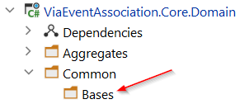
Aggregate directory
Inside Domain, create a directory “Aggregates”, this will contain a directory per aggregate in your DM. Into an aggregate directory go everything related to this aggregate: entities, owned value objects, enums, enumeration classes, repository interfaces (later session), exceptions if any, perhaps specific Result errors, etc.
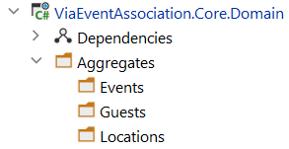
Notice each aggregate directory is plural, i.e. ending with an “s”: Events, Guests, etc. This is because I’ve had some problems with having a directory and a contained class named the same, i.e. “VeaEvent” directory with “VeaEvent” class inside.
You might also call the directories “EventAggregate” or similar.
There is already a class/concept in .NET called Event, so you cannot use this for your class. I have called mine “VeaEvent”.
It’s up to you.
The point here is we want a structured grouping of our stuff.

Common Values
You may have value objects which do not belong to a specific aggregate, so they can be put in Common/Values.
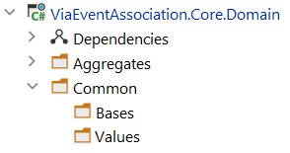
You may not need this folder now. You may need it later. Create it when you need it.

Domain Contracts (next session)
After session 5, you may need Domain Contracts. Each contract is usually used by only one aggregate, and for these, I recommend a directory under that aggregates directory, e.g.: “Domain/Aggregates/Events/Contracts”.
Alternatively, if the contract is used by multiple aggregates, I would put it in “Domain/Common/Contracts”.

Domain Services (next session)
You may also need Domain Services. Here, I suggest “Domain/Services”. These are also introduced in session 5.
A challenge with Domain Services is that they may need to retrieve data or store data, and we don’t have access to that until the next assignment, where we define the repository interfaces.
If you run into this problem, you will probably just have to mark that particular use case or scenario as “implement in assignment 5”, and leave it for now.
Alternatively, you don’t retrieve data in your services, but just receive the relevant aggregates as arguments.

Test Setup:
If you didn’t create a test project in the previous assignment, do so now. You may look at the assignment again to see how to set up a test project. Again, you may pick whichever test framework, you prefer. I use xUnit.NET.
We want a good structure for our tests. Here, we want to group our unit tests by feature, rather than layer/ring. That means you create a directory per use case, and all unit tests related to a specific use case (including all success and failure scenarios) go into this directory.
If you ever encounter an error or bug in your system, you identify which feature, and then you can easily focus on the unit tests related to this specific feature only, they are all together; not being disrupted by irrelevant tests.
This is one example:
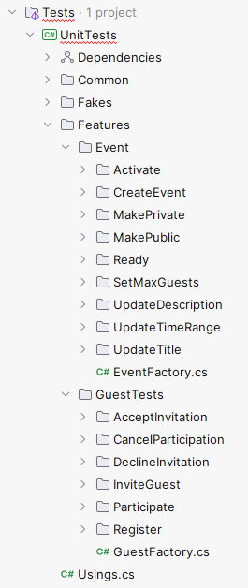
I have a Common/Values directory for shared value objects. Not all value objects belong to a specific feature, so I put all the test files for value objects in here. You may define your own approach, e.g. put the values with the feature, if that suits you better.
The Fakes directory contains stubs and mocks.
Decide upon an approach in your group. Stay consistent. You are allowed to rework the structure later, if you feel the need.

Here’s an example of my initial solution structure:
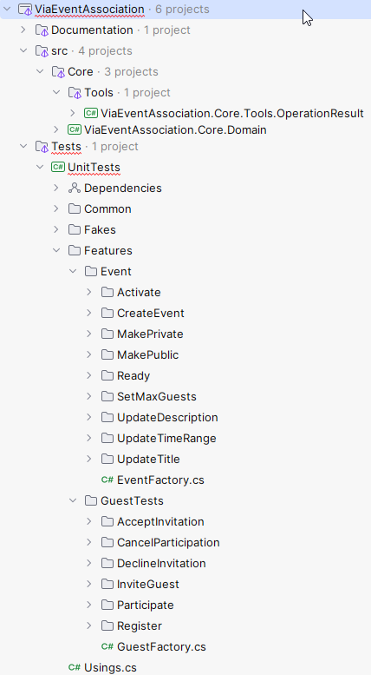

Sharing is caring
Now, you should commit at least the markdown file for the UC-implementation status, and the unit test project.
All empty directories are not committed/pushed by Git. Only when they contain files. So, I suggest you don’t create the directories until needed, and then are diligent at pushing/updating right away.

3 Your Task
First:
- Base classes
Implement each of the base classes: ValueObject, Entity, AggregateRoot. Get inspiration from session 2.
- Domain Model
Implement the domain model, work your way through the use cases. For each use case, first do the necessary value object(s), then the functionality on the domain model. Consider where logic should go: Value, Entity, or Service/Contract.
Do everything through TDD, i.e. try to write a failing test first, then implement the functionality.
- Test structure
Name your unit test files like this:
- CreateEventAggregateUnitTests. I.e <Feature>AggregateTests.
- EventDescriptionUnitTests. I.e. <ValueObjecType>UnitTests.
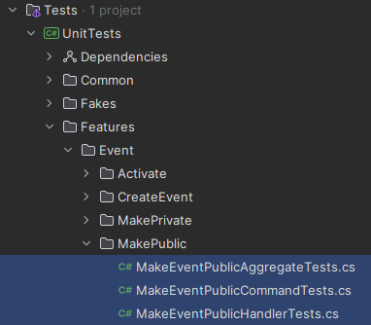
Later we will have more tests for the same feature, as we expand the system, and we will have files like: CreateEventCommandHandlerUnitTests, CreateEventCommandDispatcherUnitTests, etc.
All classes in a directory are about the same feature, but from different entry points in the system.

Notice: some use case scenarios cannot be done until you have heard about Domain Services and Domain Contracts, in session 5.

- Encapsulation
Make relevant parts of you DM “internal”, and use the “friend assembly” approach, so you can reach into the aggregate and verify its state.
Generally, be careful about letting your tests drill down into the entities to check state, as this will tie tighter to implementation details, so you may consider adding internal accesser-methods/-properties or similar to the aggregate root class, which can provide access to the state of owned entities/values. Use your best judgment here, it is a balance.

- IDs
You must use strongly typed IDs, i.e. EventId, GuestId, LocationId, etc. This provides clarity in your code, and compile time checks for arguments.
It may feel like more work than just Guids, but as with many cases in this course: now you try it, and can then decide if you will use it again in other projects.
“
By using strongly-typed IDs like these we can take full advantage of the C# type system to ensure different concepts cannot be accidentally used interchangeably. Using these types in the core of your domain will help prevent simple bugs like incorrect argument order issues, which can be easy to do, and tricky to spot!
“ - An introduction to strongly-typed entity IDs (andrewlock.net)
You must make a generic Entity base class, where the generic type parameter will be the type of the ID, given in the sub-class, e.g. “public class VeaEvent : Entity<EventId>”.

- Naming (if doing VIA Event Association):
“Event” is already a keyword in .NET, so it causes issues if you name your entity “event”. You can e.g. Call it VeaEvent, or EventAggregate, or EventRoot, or something similar.

- Feature status file
Add a markdown file to the Assignment4 directory, where you keep track of which features have been completed, and which are missing. It could look something like:
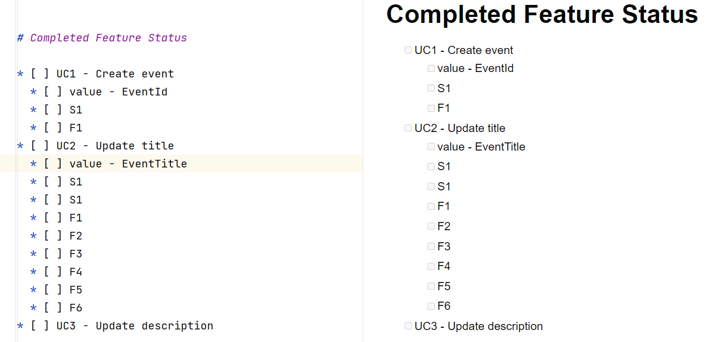
This is so I can see how far you’ve come in your implementation. You may also add notes, e.g.:
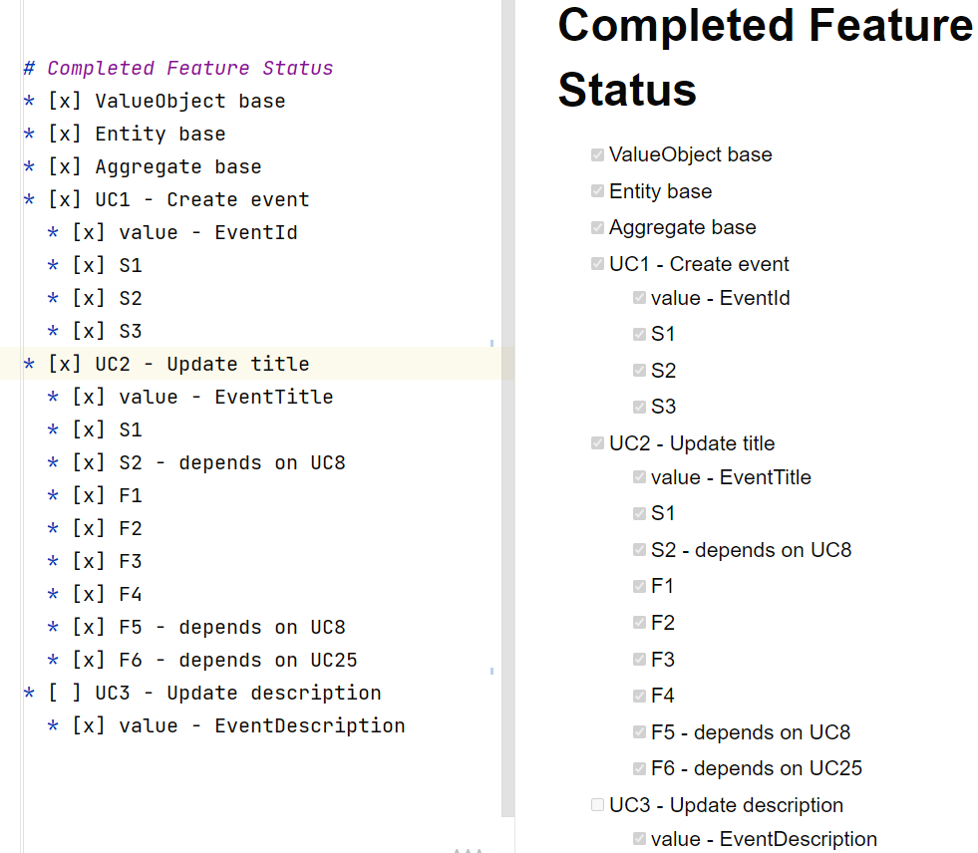
It can be a good idea to track progress elsewhere too, e.g. Trello, Meistertask, or similar online task tracking tools. But that is for your own benefit, I’m not interested in that.

Note: I do not necessarily expect you to finish all use cases. But it would be great if you reach the “nice to have” features, as I believe until then, the aggregate pattern for the domain model does not really show its usefulness.

- Beyond the “need to have” requirements
If you get to the use cases, which are not described in detail, and wish to implement these, you must create use case documentation with user story, and success/failure scenarios, and think about all the ways the use case can succeed or fail.
I will be curious to see how you approach this detailed analysis yourself.
Include this documentation in your hand-in, in the doc/assignment-4 directory.

- Factory for testing (Optional requirement!!)
This part is optional, just a suggestion. I have benefited from making an EventFactory (and GuestFactory) class, to easily construct events in different states, e.g.:
VeaEvent veaEvent = EventFactory.Init()
.WithStatus(EventStatus.Active)
.Build();

You would then have various “WithX” methods, to set different parts of the event to be created. It uses the Fluent Builder pattern, and it reduces code repetition.
See the slides, I mentioned this.

- Updated Concrete Domain Model
You must also include your concrete domain model diagram, and it must match your implementation. If, during your implementation, you reworked your design, the diagram must be updated.

Formalities
- Feedback on the project?
Any feedback you encounter, put this in a markdown file. Is something in the project descriptions unclear? Is information missing? Are use case scenarios missing, unclear, wrong? Anything else at all?
As this is a first iteration of the course, any feedback is valuable.

If you do any research yourselves, and find relevant sources, please put these in the markdown file as well.

- Handing in
The assignment is handed in on itslearning, you just put in a link Domain project on GitHub.
Deadline will be posted on itslearning.

